UNIT 4
Q1) Comparison Between Finite Automata (FA) and Push Down Automata (PDA)
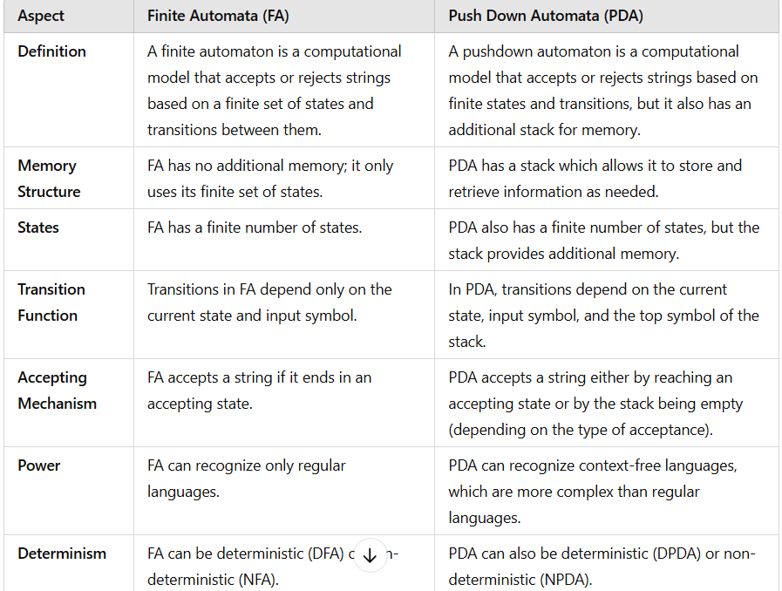
--------------------------------------------------------------------------------------------------------------------------------------------------
Q2) Post Machine
In 1936, Emil Post introduced a simplistic model which is known as Post’s Machine. This machine has a capability to accept any language that can be precisely defined by human beings.
This machine is more powerful than finite automata and push down automata. That means it can accept regular, non-regular, context-free and non-context-free languages.
The Post Machine (PM) is a collection of following things -
1. The set of input letters denoted by ∑, along with a special symbol #.
2. The linear storage location in which the input symbols can be placed. Such a location is called STORE or QUEUE. The symbols can be inserted in this QUEUE from one end and deleted from other end.
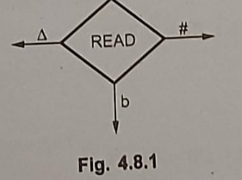
3. The READ state which is deterministic in nature.
4. The ADD state used to insert the symbol in queue.
5. The START state, ACCEPT and REJECT states. The ACCEPT state in usually halt state.
The post machine is normally deterministic in nature but sometimes non-deterministic post machine is also used.
Working of a Post Machine:
- The machine begins with a string of symbols written on the tape.
- The machine reads the tape from left to right and applies the first rule it encounters (or rules, if multiple rules apply). This results in the modification of the tape.
- The machine then continues reading the tape and applies more rules, repeating this process until no more applicable rules can be found or until the machine halts.
Q3)Define Push down Automata. Explain different types of PDA. Explain any two applications of PDA. [8]
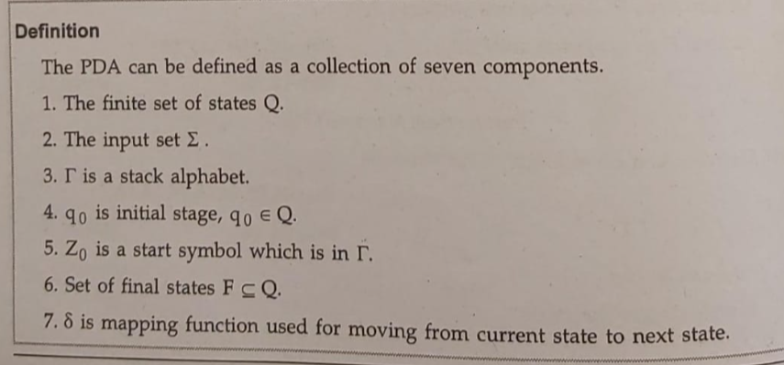
- The push down automata will have input tape, finite control, and stack.
- The input tape is divided in many cells. At each cell only one input symbol is placed thus certain input string is placed on tape.
- The finite control has some pointer which points to the current symbol which is to be read.
- At the end of input $ or Δ (blank) 'b' (blank) symbol is placed which indicates end of input.
- The stack is such a structure in which you can push and remove the items from one end only.
- In the push down automata, we are using the stack for storing the items temporarily.
- Inserting the symbol onto the stack is called push operation and removing a symbol from stack is called pop operation.
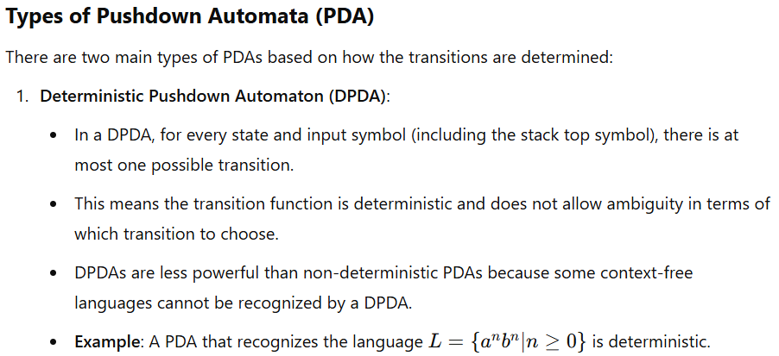
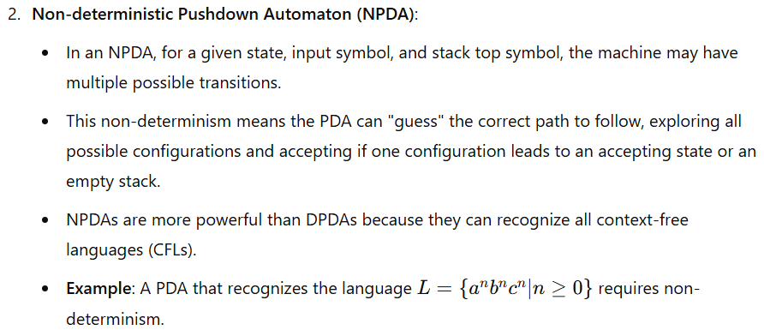
Applications of Pushdown Automata
1. Compiler Design (Parsing) : One of the most important applications of PDAs is in parsing in the design of compilers. PDAs are used in syntax analysis to process the grammar of programming languages, which is often context-free.
In parsing, the input string is processed symbol-by-symbol, and the stack is used to store intermediate results. The PDA ensures that the structure of the input string matches the grammar's production rules.
For example, a PDA can be used to check whether a string of parentheses is balanced, which is a typical application of context-free languages.
2. Syntax Checking for Balanced Parentheses and Nested Structures
Another practical use of PDAs is in the validation of balanced parentheses, which is essential in many programming languages. A PDA can easily verify whether every opening parenthesis has a corresponding closing parenthesis, and it can also handle other nested structures like brackets, braces, and even HTML/XML tags.
The PDA accepts the string if, after reading the entire string, the stack is empty (indicating all opening symbols have been matched with closing symbols).
For example:
- The string "(a + b) * (c + d)" is valid because every opening parenthesis has a matching closing parenthesis.
- The string "(a + b * (c + d)" is invalid because the parentheses are not balanced.
--------------------------------------------------------------------------------------------------------------------------------------------------
Q4) Write a note on Instantaneous Description of PDA with an example
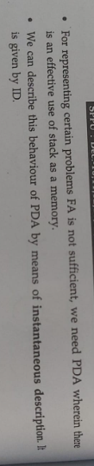
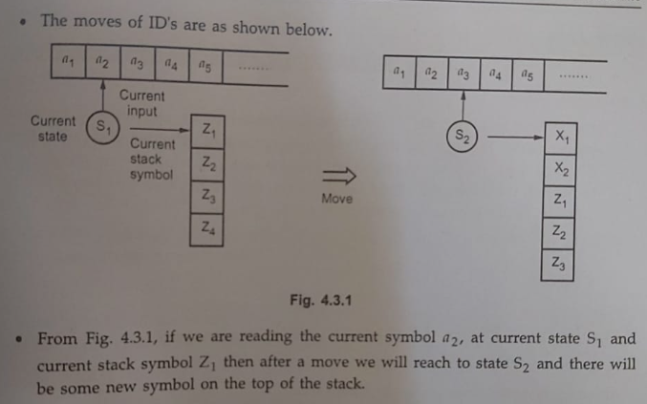
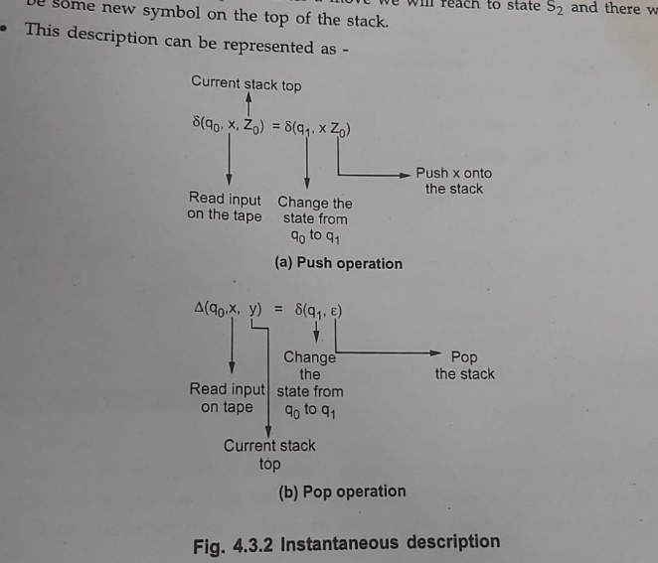
Q5) Explain the acceptance by PDA [6] i) By final state ii) By empty stackA
Pushdown Automaton (PDA) can accept an input string in two distinct ways:
1. Acceptance by Final State
2. Acceptance by Empty Stack
These two methods of acceptance define how a PDA determines whether a given string belongs to the language it recognizes.
i) Acceptance by Final State
In the acceptance by final state method, the PDA accepts an input string if, after processing the entire input string, it reaches an accepting (final) state. The stack contents are not necessarily important in this case. The primary condition for acceptance is that the machine must be in a final state when the input string is completely read.
Process:
1. The PDA starts in its initial state and begins processing the input string symbol by symbol.
2. The PDA uses its transition function to move between states and possibly push or pop symbols onto/from the stack based on the input symbol.
3. If, after reading the entire input string, the PDA ends in one of its accepting states, then the input string is considered accepted.
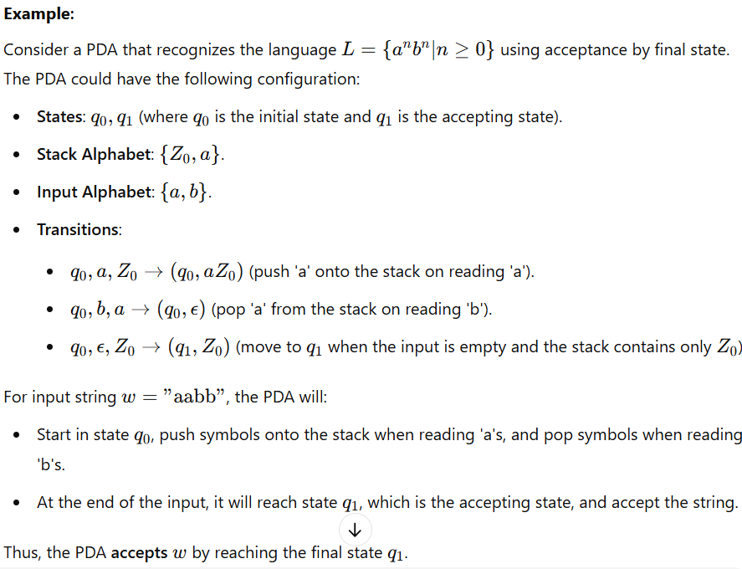
ii) Acceptance by Empty Stack
In the acceptance by empty stack method, the PDA accepts an input string if, after processing the entire input string, the stack is empty. The final state is not necessarily important here. The primary condition for acceptance is that the stack should be empty after all input symbols are processed.
Process:
1. The PDA starts in its initial state and processes the input string symbol by symbol.
2. During the processing, the PDA pushes symbols onto the stack when reading certain input symbols and pops symbols from the stack when reading others.
3. If, after reading the entire input string, the stack is empty, the PDA accepts the string, regardless of the state it ends in.
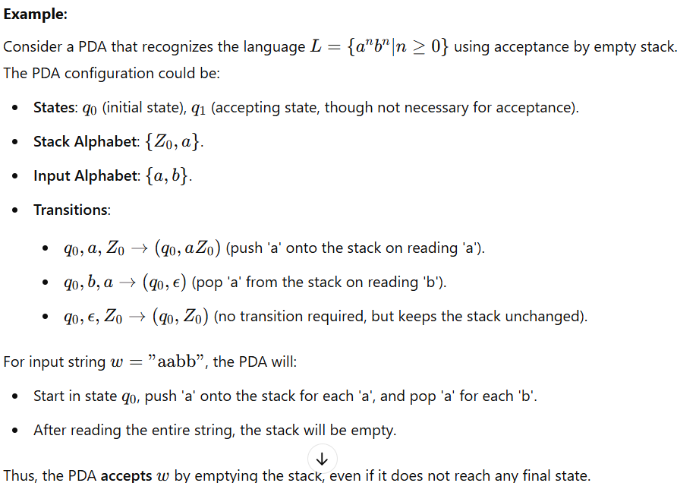
Comparison of the Two Methods
- Acceptance by Final State:
  - The machine accepts the string if it ends in an accepting state after consuming the entire input.
  - The stack contents are not important.
  - It is easier to implement for simple languages where the state alone determines the acceptance condition.
- Acceptance by Empty Stack:
  - The machine accepts the string if the stack is empty after consuming the entire input, regardless of the state.
  - It is often used in more complex languages, especially when the stack is critical for determining the acceptance condition.
  - This method provides more flexibility but may require more careful management of the stack during the computation.
--------------------------------------------------------------------------------------------------------------------------------------------------

